Explore the role of logic circuits in real-world systems such as microprocessors, memory units, or control systems, and choose a specific application (e.g., arithmetic logic unit or multiplexers) to describe how logic circuits are utilized in that application.

**4. Real-World Applications of Logic Circuits**

Introduction

Arithmetic Logic Unit (ALU) is one of the fundamental building blocks of digital computing hardware. It performs arithmetic operations such as addition, subtraction, multiplication, and division, as well as logical operations such as AND, OR, XOR, and NOT. The ALU directly impacts the performance and the speed of a system as a whole, not only deciding the computation capacity but also power consumption and processing efficiency.  
  
With the intricacy of today's computing increasing, the ALU has also risen significantly in terms of size, speed, and capability. This paper examines the design principles in the ALU, the organization, and even in real-world applications to other fields like embedded systems, cryptography, and digital signal processing. The paper will cover challenges faced in designing ALUs and discuss future directions revolutionizing ALU technology.

Fundamentals of Digital Logic  
Understanding the fundamentals of digital logic is essential before learning the ALU. Boolean algebra is the foundation of digital circuits that perform logical functions on binary numbers 0 & 1. The fundamental logical operations are:  
  
**AND (A ∧ B):** Produces a true (1) output only if both inputs are true.

**OR (A ∨ B):** Produces a true (1) output if one or both inputs are true.

.**NOT (¬A):** Reverses the value of the input.

.**XOR (A ⊕ B):** Produces a true (1) output only if the inputs differ.

NAND, NOR, and XNOR: These are special cases of the AND, OR, and XOR logical operations that see frequent usage in digital circuit minimization.

Logic gates such as AND, OR, NOT, NAND, NOR, XOR, and XNOR are the building blocks of digital circuits. These gates combined can implement complex operations, even those performed by an ALU.

Truth tables and boolean algebra

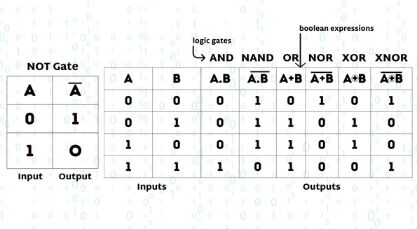

Types of Logic Gates - AND, OR, NOT, NAND, NOR, XOR, XNOR

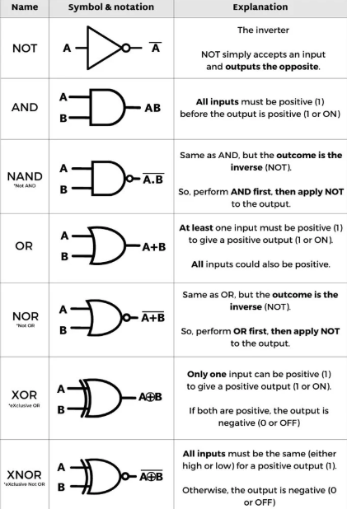

Image source: <https://computerengineeringforbabies.com/blogs/engineering/logic-gate>

**Architecture of ALU**

An ALU comprises several sub-units that function together to carry out different operations. The main components are:

**Operand Registers:** These registers hold the input data that are operated on by the ALU. The operands are typically two 32-bit or 64-bit values, but smaller or larger registers may be used depending on the application.

**Arithmetic Unit:** This unit does arithmetic operations like addition and subtraction. It uses adders, subtractors, and sometimes multipliers for multiplication. A simple ALU might use a ripple-carry adder or carry-lookahead adder to do these operations.

**Logical Unit:** The logical unit performs the bitwise AND, OR, XOR, and NOT on the operand data. They need to do most control and decision-making functions in digital circuits.

**Multiplexer:** Multiplexer is utilized for selecting the operation to be performed by the ALU. Multiplexer is provided with control signals as inputs and selects which arithmetic or logical operation has to be performed. It is a component that comes into play to get the ALU to perform more than one operation.

**Flags and Status Registers:** The status registers hold flags for representing some conditions after an ALU operation. These flags tend to be the carry flag, zero flag, overflow flag, and sign flag. For example, after an add operation, the carry flag will be set if the result of the operation is greater than the maximum value representable in the result.

Block Diagram of an ALU

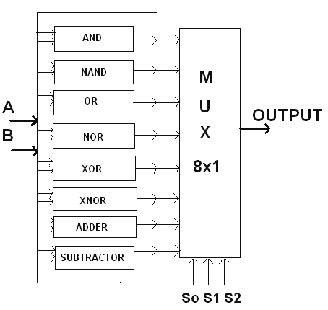  
Image source: <https://www.researchgate.net/figure/Block-diagram-of-an-ALU_fig1_251093842>

Design and Implementation of ALU

The design of an ALU will depend on the operations and the number of bits it carries out. A simple 4-bit ALU can be developed using combinational logic circuits and sequential circuitry. It entails the process of:

**Basic Arithmetic Circuits:** Arithmetic in the ALU is performed by adders and subtractors. The most widely used adder is the full adder, which calculates on two bits and an additional carry-in bit to produce a sum and carry-out bit. Carry-lookahead adders or CLA are faster than normal ripple-carry adders since they reduce the propagation delay via the anticipation of carries.

**Logical Circuits:** These logical functions like AND, OR, XOR, and NOT are derived utilizing basic logic gates. The combination of these gates is utilized in the ALU to perform operations in a sophisticated yet efficient method.

Control Logic Design: The control unit of the ALU decides which operation to perform. It does so by employing multiplexers and decoders that drive the input data onto the correct circuit paths.

block diagram of a 4bit ALU for operations and, or, xor and add  
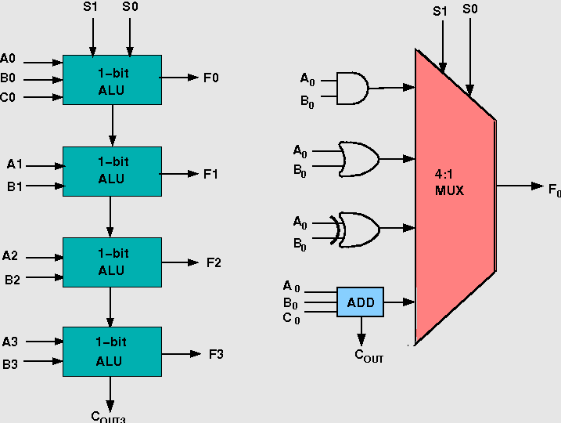

Image source: <http://vlabs.iitkgp.ac.in/coa/exp8/index.html>

Boolean Algebra and Logic Gates in ALU Function

Boolean expressions define the behavior of digital circuits, and their optimization maximizes circuit efficiency. Logic gates implement expressions in hardware, allowing for efficient implementation of computational operations. Boolean algebra is crucial for reducing the digital circuit logic. For example, Karnaugh maps (K-maps) are used to simplify Boolean expressions & reduce the number of logic gates in ALU design. Reduction of Boolean expressions minimizes the number of gates required, leading to more power-efficient, faster, & smaller ALUs.

**Boolean Expression Simplification:**

Simplification techniques such as Karnaugh maps are employed to reduce ALU designs so that they implement fewer logic gates. For instance, the Boolean expression for an ALU operation can be reduced by grouping terms together in a Karnaugh map, minimizing the logic implementation.

K-map

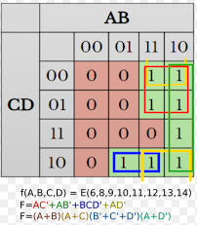

Image source: <https://en.wikipedia.org/wiki/Karnaugh_map>

Practical Applications of ALU

ALU is used in various computing and embedded systems like:  
  
**- CPUs and Microprocessors:** Microprocessors contain ALUs, where they execute arithmetic and logical computations. Modern processors like Intel's Core processors and AMD Ryzen processors have highly optimized ALUs that do complex computations in parallel, which helps in faster computation.

**- Embedded Systems:** Microcontrollers like Arduino and Raspberry Pi contain ALUs to execute various operations in embedded systems, including robotics, automation, and sensor control. The systems have a minimal instruction set with the requirement for very efficient ALUs to ensure real time output.

**- Digital Signal Processing (DSP):** In this application, ALUs perform complex mathematical computation within multimedia and communications, including video, sound, and image processing. Logical and arithmetic operations like Fourier transforms, convolution, and filtering are essential in multimedia and communication systems.

**- Cryptographic Applications:** ALU Performs encryption and decryption operations that are integral in cybersecurity & secure communication, performing logical and arithmetic operations. ALUs provide high speed data manipulation required for secure communication & cybersecurity.

ALU Operation Selection Flowchart  
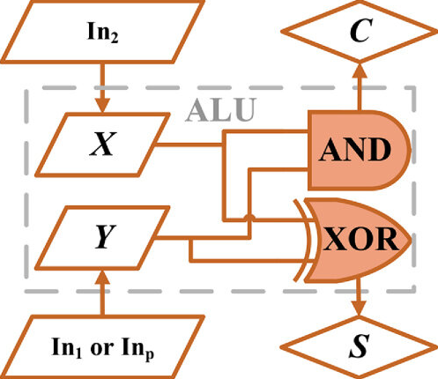

Image source: https: <https://www.researchgate.net/figure/Flow-chart-on-the-arithmetic-logic-process-of-the-proposed-ALU_fig3_374603687>

Design Challenges in the ALU

When engineers design an ALU, they are confronted with issues like:

**- Power Consumption:** New ALUs must balance performance and power efficiency, particularly in battery operated systems. Designers have to compromise on performance and power consumption in designing ALU using clock gating and power saving adders to maintain energy usage at the lowest levels.

**- Speed Optimization:** Methods such as Look-ahead Carry Adders (LCA) minimize propagation delays, thus decreasing computation time. Look-ahead adders & carry Adders are used to reduce the speed by shortening the period of propagations of carries during arithmetic computation. Additionally, pipelining and parallelism are also being utilized in modern ALUs in order to optimize performance further

.

**- Circuit Complexity:** Effective hardware without a loss of function requires innovative design methods like RISC ALUs. The more complex processors become, the more difficult it is to design multiple task ALUs. Engineers have to make sure that circuit complexity should not stop the ALU's efficiency or speed.

**- Scalability:** For improving efficiency in high-performance computing, parallel processing and pipelining should be implemented. Scalable ALU designs are essential in high-performance computing systems. Parallel processing and pipelining are important to improve efficiency to increase efficiency with a rise in the number of processing units in multi-core processors.

Conclusion

The Arithmetic Logic Unit is the core of digital computing because it enables both arithmetic and logical functions. The design and construction of the ALU constitute a synthesis of Boolean algebra, logic gates, and control circuitry. With the demand for more processing power and speed showing no signs of slowing, ALU design advances in the future are positioned to push computational performance in a variety of applications, ranging from consumer products to artificial intelligence.

## References

<https://en.wikipedia.org>

<https://www.geeksforgeeks.org>

<https://www.researchgate.net>